Training Preparation Resources
The staff at Policy Research Associates/SAMHSA’s GAINS Center are committed to providing effective training for our TTT participants. To assist you in preparing for your upcoming practice sessions, we would like to introduce you to two online resources that other trainers (new and returning) have found to be helpful. These resources include the comprehensive, slide-by-slide overviews of each training module (i.e., Training Module Talkbacks) and the filmed, in-person “gold standard” delivery of the six-module Trauma Training (i.e., Training Demonstration).
Please recall that it is important that you make this training yours. You may use the examples and stories presented in the training resources, but feel free to incorporate other materials to more effectively communicate the training content to specific groups of participants in your future training deliveries.
Both of the above noted resources will be found on the password-protected trauma trainer website.
Begin by going to the SAMHSA’s GAINS Center website: http://www.samhsa.gov/gains-center
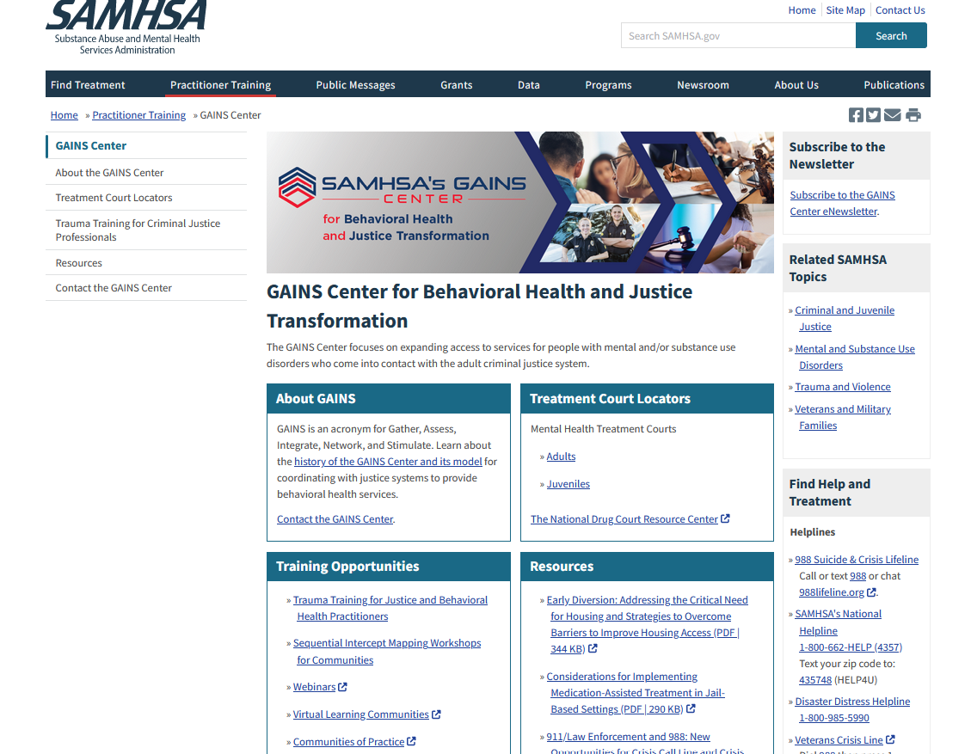
Scroll down to the Training Opportunities box on the lower left of the page. Click on “Trauma Training for Justice and Behavioral Health Practitioners”. This will redirect you to the Trauma Trainer information page.
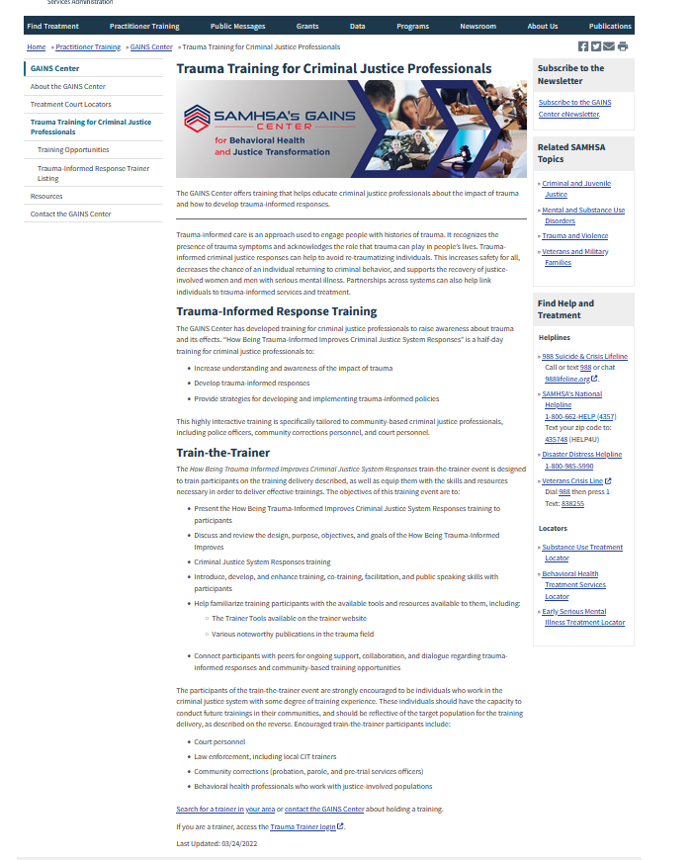
Go to the bottom of this page and click on Trauma Trainer Login (see circled link). You will be redirected to the Policy Research Associates (PRA) webpage at https://www.prainc.com/trauma-informed-training/. Log in to the password protected trainer portal using the following information. This information is the same for all trainers and may also be found in your Trainer Guide.
Username: gains1training
Password: Trauma_Informed1!

Click the tab for the organization from which you received training, Policy Research Associates (PRA) or SAMHSA’s GAINS Center, then click on Criminal Justice Training Version 4.0.
You are now on the Version 4.0 Trainer Resource page. Midway down the page you will see labelled sections for Training Demonstrations and Training Module Talkbacks.

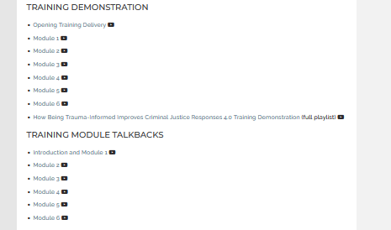
The Training Demonstration section contains links to videos of each of the six modules being delivered by a master trainer. You are welcome to watch these as a refresher of training content.
The Training Module Talkbacks section includes narrated discussions of key talking points and delivery tips for each of the six modules.

