

How Being Trauma-Informed Improves

Criminal Justice System Responses

Facilitator Bios

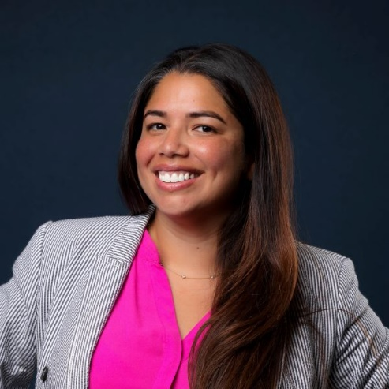

Michelle Espinosa-Clark, MPA joined Policy Research Associates, Inc. (PRA) in January of 2022. She is Senior Project Associate with SAMHSA’s GAINS Center. The GAINS Center focuses on expanding access to services for people with mental and/or substance use disorders who encounter the justice system. Prior to joining PRA, Ms. Espinosa-Clark was the Misdemeanor Jail Diversion (JDP) Team Leader with the Eleventh Judicial Circuit of Florida Criminal Mental Health Project. She was responsible for coordination, administration, and supervision of program operations of the Misdemeanor Mental Health Programs (Misdemeanor Crimes, Assisted Outpatient Treatment (AOT) and Domestic Violence Mental Health Dockets). She has extensive history working with community stakeholders to help people access community-based mental health treatment and services so they may be diverted from the criminal justice system and jail. Michelle completed her bachelor’s degree from Pennsylvania State University and earned her master’s degree in Public Administration from Nova Southeastern University. She is a certified person-to-person case manager, a WRAP (Wellness Recovery Action Plan) facilitator and a certified SOAR (SSI/SSDI Outreach, Access, and Recovery) entitlement specialist. Ms. Espinosa-Clark is also certified to provide Sequential Intercept Model (SIM) mapping workshops and train-the-trainer workshops for PRA’s Trauma Training for Criminal Justice Professionals.

How Being Trauma-Informed Improves

Criminal Justice System Responses


Erika Ihara, MA, MS

Erika Ihara, MA, MS is a Project Associate at Policy Research Associates (PRA), providing program coordination and project management for SAMHSA’s GAINS Center for Behavioral Health and Justice Transformation. She serves as coordinator of the GAINS Center’s national How Being Trauma-Informed Improves Criminal Justice System Responses training program and is a member of the GAINS Center’s communications staff producing the national webinar series for SAMHSA’s GAINS Center.
She has held previous positions in educational program coordination and research at the University at Albany (SUNY) School of Public Health, New York University School of Medicine, and Institutional Investor (II) Magazine, and is a former member of the adjunct faculty at State University of New York (SUNY) Empire State College. She received her Master of Science in Educational Administration and Policy Studies from the University at Albany (SUNY), Master of Arts in Art History from the University of California, Irvine, and Bachelor of Arts in Liberal Arts from the University of Chicago.

How Being Trauma-Informed Improves

Criminal Justice System Responses

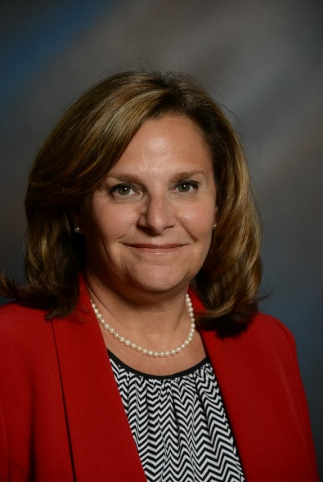

Cindy A. Schwartz, MS, MBA is a consultant with Policy Research Associates and SAMHSA’s
GAINS Center for Behavioral Health and Justice Transformation. She served previously as
Project Director of the Eleventh Judicial Circuit of Florida Criminal Mental Health Project- Jail
Diversion Program. Her career goals have been focused on promoting system transformation,
community integration and recovery. Cindy has a master’s degree in Rehabilitation Counseling
from the State University of New York at Buffalo and a Masters in Business Administration
from Nova Southeastern University. Cindy is actively involved in her community and serves on a variety of professional organizations, boards and committees.

How Being Trauma-Informed Improves

Criminal Justice System Responses

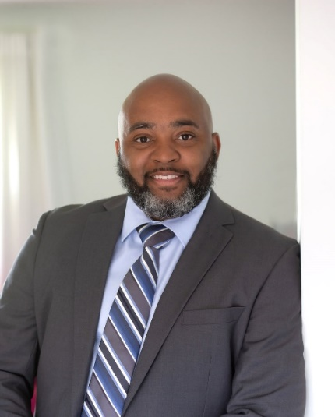

John Watts, DCJ
Dr. John Watts is a criminal justice practitioner and educator with over 20 years of experience working in the criminal justice system. Currently, he serves as a chief probation officer with the State of Connecticut Judicial Branch and adjunct professor at Gateway Community College. John is a consultant with the SAMHSA’s GAINS Center and Policy Research Associates, he holds certifications as a Criminal Justice Addiction Professionals (CCJP) and in Forensic Cognitive Behavioral Therapy (F-CBT). John has a bachelor’s degree in liberal arts from Charter Oak State College, a master’s degree in management and organizational leadership from Albertus Magnus College and a doctorate degree in criminal justice from Saint Leo University.

