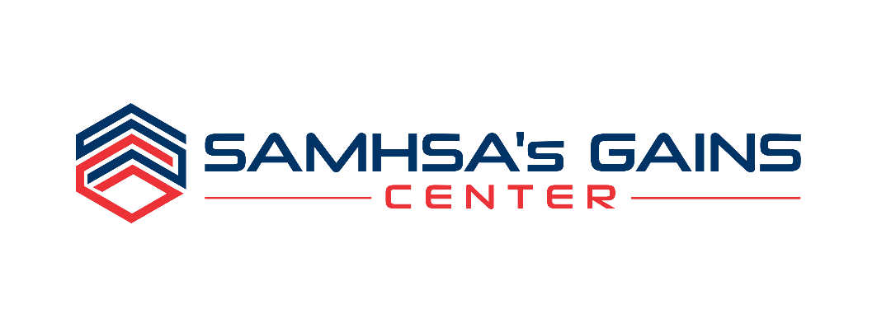

Solicitation for Applications

Sequential Intercept Model (SIM) Mapping Workshops to
Develop Comprehensive, Community-Wide Strategic Plans for Addressing Substance Use

Please complete this application in its entirety to ensure that we have SUFFICIENT background information on your Jurisdiction and that the Required level of commitment among Key Stakeholders is CLEARLY demonstrated.
NOTE: Incomplete applications will not be considered.

PLEASE RETURN THIS APPLICATION VIA E-MAIL BY October 18, 2024:

Attn: Ashley Sabatino, SIM Mapping Workshop Coordinator
E-mail: asabatino@prainc.com
Phone: 1.800.311.4246 or 518.439.7415 Ext. 5277

SAMHSA’s GAINS Center
Policy Research Associates, Inc.
433 River Street, Suite 1005
Troy, NY 12180

NOTE: Strong preference for single PDF submissions.

Overview
SAMHSA’s GAINS Center for Behavioral Health and Justice Transformation, operated by Policy Research Associates, Inc. (PRA), is known internationally for its work regarding individuals with behavioral health needs who are involved in the criminal justice system.

For the past several years the GAINS Center has solicited applications from jurisdictions interested in better identifying and responding to the needs of individuals with behavioral health needs who are involved or at risk for involvement in the criminal justice system, through Sequential Intercept Model (SIM) Mapping Workshops. The workshops are designed bring together a local, cross-system, multidisciplinary group of key stakeholders from a particular jurisdiction to facilitate cross-system collaboration and to identify and discuss ways in which barriers in and between the criminal justice and behavioral health systems can be reduced through the development of integrated local strategic action plans.

This solicitation targets communities that are particularly interested in developing comprehensive, community-wide strategic plans for addressing substance use, and better identifying and responding to the needs of adults with substance use disorders who are involved or at risk for involvement in the criminal justice system. Applications should emphasize resources, gaps and opportunities, as well as commitment among key stakeholders to addressing these issues.

The SIM Mapping Workshops will focus specifically on identifying and treating individuals with substance use disorders across all of the intercepts, including screening and assessment, diverting individuals out of the criminal justice system and into appropriate community-based treatment programs, access to medications for Opioid Use Disorder, and maintaining continuity of care through transitions in and out of custody. SIM Workshop participants are expected to be drawn, in large part, from criminal justice and behavioral health agencies and organizations. 911 dispatch, crisis services, law enforcement and other first responders, hospitals, jails, courts (particularly drug courts and other treatment/problem-solving/specialty courts), reentry services, probation and parole, and community-based behavioral health treatment providers, are all essential participants in these workshops.

Purpose & background

SIM Mapping Workshops result in a map that illustrates how adults with behavioral health needs come in contact with and flow through the criminal justice system utilizing the framework of the Sequential Intercept Model. The workshops bring together key stakeholders to create a local “systems map” and establish local priorities for change and strategic plans.

The Sequential Intercept Model

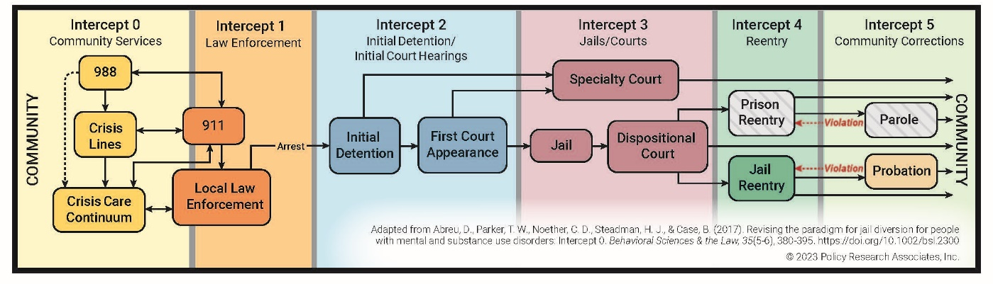

During the SIM Mapping Workshop, resources and opportunities are identified at each intercept for identifying individuals with behavioral health needs (particularly substance use disorders) and diverting them out of the criminal justice system and into appropriate community-based treatment programs. As part of the mapping process, critical gaps are also identified and summarized. Based on the identified gaps, opportunities for improvement and systems change are discussed. Participants determine areas where immediate action will result in a more cohesive, integrated approach to service delivery, and a local set of priorities for change is established. The local set of priorities for change become the focus of strategic action plans. Throughout this process, the GAINS Center staff provide examples of successful systems integration and promising programs from around the country.

As mentioned previously, this solicitation targets communities that are interested in developing comprehensive, community-wide strategic action plans for addressing substance use. SAMHSA’s GAINS Center will conduct SIM Mapping Workshops focused on resources, gaps and opportunities for identifying and treating substance use disorders across all the intercepts of the SIM, including screening and assessment, diverting individuals out of the criminal justice system and into appropriate community-based treatment programs, implementing or expanding MAT, and maintaining continuity of care through transitions in and out of custody.

Best practices across the intercepts include cross-systems collaboration and coordination, screening and assessment for substance use disorders, access to treatment and recovery supports, continuity of care (particularly during transitions in and out of custody), data collection and data/information sharing, and cross-system efforts to identify and address racial inequities and disparities.

Intercept 0 resources, gaps and opportunities will be examined during the workshops including review of community education efforts around substance use, resources that exist in the community to identify and treat substance use disorders including detox facilities and providers, availability and distribution of overdose reversal tools and other harm reduction initiatives, and access to essential recovery supports.

Intercept 1 resources, gaps and opportunities will be examined during the workshops including the role of 911 dispatch/emergency services and law enforcement in responding to substance use crises, co-response, and warm handoffs to treatment providers and/or peers, and various pre-arrest diversion models.

Intercept 2 resources, gaps and opportunities are examined during the workshops including review of initial detention and arraignment processes, screening and assessment procedures, pre-trial services, eligibility requirements and referral processes for participation in drug courts and other treatment/problem-solving/specialty courts, and various post-arrest diversion models.

Intercept 3 resources, gaps and opportunities are identified during workshops, including a review of drug court and other treatment/problem-solving/specialty court structure, staffing, capacity, treatment planning and case management, linkage to community-based substance use treatment providers, and availability of substance use treatment and recovery supports in jails and prisons.

Intercept 4 resources, gaps and opportunities are examined during the workshops, including review of re-entry/transition planning by jail staff or community partners, medication and prescription access upon release from jail or prison (including continuity of MAT), warm handoffs to community-based substance use treatment providers, and access to housing, Social Security, Medicaid, and other supports.

Intercept 5 resources, gaps and opportunities are examined during the workshops, including review of specialized probation and parole caseloads, the role of probation and parole in assisting individuals with access and continued engagement in substance use treatment, and access to access to housing, Social Security, Medicaid, and other supports.

By facilitating cross-system communication and collaboration, the SIM workshops help communities improve the early identification of individuals with behavioral health needs coming into contact with the criminal justice system, increases effective service linkage, reduces the likelihood of individuals cycling through the criminal justice system, enhances community safety, and improves quality of life for all people in the community.

Site Selection

SAMHSA’s GAINS Center for Behavioral Health and Justice Transformation will provide SIM Mapping Workshops free of charge to selected jurisdictions between February and August 2025. There are no fees for registration, tuition, or materials associated with these workshops. The GAINS Center will cover all costs associated with pre- and post-workshop planning and coordination, facilitator time, data collection and analysis, and report development.

To be considered, all applications must be received by October 18, 2024. Selected communities will be notified by November 15, 2024.

target audience/Workshop Participants

The target audiences for this workshop are criminal justice and behavioral health system professionals, including 911 dispatch, crisis services, law enforcement and other first responders, hospitals, jail administrators and correctional officers, judges, prosecutors, defense attorneys, court coordinators (particularly for drug courts and other treatment/problem-solving/specialty courts), reentry services, probation and parole officers, behavioral health treatment providers, and persons with lived experience. Since the workshop is highly interactive in nature, to achieve maximum participation for all attendees, each workshop is limited to 60 participants.

TARGET ATTENDEE GROUPS:
- Criminal Justice System Professionals (judges and court personnel, prosecutors, defense attorneys, dispatchers and law enforcement, jail administrators and correctional officers, pre-trial services, re-entry service providers, probation and parole officers)
- Substance Use Professionals (chemical dependency counselors, substance use specialists, supervisors, program managers, administrators, etc.)
- Mental Health Professionals (psychologists, psychiatrists, social workers, supervisors, program managers, administrators, etc.)
- First Responders/Crisis Services (EMS, mobile crisis, detox services, suicide prevention staff, DV workers)
- Peers and Family Members (persons with lived experience in the local behavioral health and criminal justice system), including local Peer-Run and Family-Run Organizations
- Housing and Community Support Services (housing providers, local Social Security and Medicaid agency representatives, etc.)
- Religious and Cultural Organizations and Local Foundations
- Elected Officials

KEY STAKEHOLDER PARTICIPANTS:
- Judges (particularly those who preside over first appearance courts, drug courts, and other treatment/specialty courts)
- Drug/Treatment Court Coordinator(s) and Case Managers
- Re-entry staff and leadership;
- District Attorney’s Office
- Public Defender’s Office
- Administrators from the local police department(s) and county sheriff’s office;
- Administrator from the local jail;
- Administrator from the local probation department(s);
- Administrator from the local public mental health agency (e.g., county mental health department);
- Administrator from the local public substance use agency;
- Administrator from the local housing authority;
- Administrators from the local Social Security and Medicaid agencies;
- Individuals with lived experience in both the criminal justice and behavioral health systems

Application Requirements

It is required that each jurisdiction submitting an application for consideration identify and engage leaders within their community that support this project and are dedicated to allocating staff time to participate in the workshop and related activities.

Please include letters of support that specifically demonstrate commitment to addressing the issue of substance use on a community-wide basis from the following (*are required, as applicable):

- Judge(s) and/or treatment court coordinator(s) – demonstration of drug court involvement/commitment is a priority for this solicitation*
- Re-entry service provider agency(ies) – also a priority for this solicitation*
- Law Enforcement*
- Sheriff or Jail Administrator*
- Mental health and substance use services*
- Pre-trial services
- District Attorney’s Office
- Public Defender’s Office
- Probation*
- Housing
- Social Security and Medicaid

Additionally, applicants selected to receive SIM Mapping Workshops must agree to participate in the following:

- 2-3 pre-workshop planning conference call(s) with GAINS Center staff and consultants;
- Local planning activities on an as needed basis to select workshop dates, identify and invite workshop participants, etc.
- Pre-workshop inventory of existing resources, policies, and programs;
- Pre-workshop community self-assessment of level of collaboration and perceptions of criminal justice and behavioral health issues (repeated at 6- and 12-months post-workshop);
- Pre-workshop data collection around specific community impact measures and progress indicators (repeated at 6- and 12-months post-workshop);
- 1.5 day in-person workshop.

Following the workshop, communities will receive a list of identified priorities for change, copies of draft local strategic action plans, a full comprehensive report, and a detailed systems map. Additionally, communities will be provided with the results of the community self-assessment and quantitative and qualitative data and information regarding the impact of the workshop and progress following it.

Since the SIM Mapping workshop is designed to bring jurisdictions that may be at varying “points of readiness” through a series of exercises that culminate in a comprehensive systems map and a set of local priorities for change with concrete action steps, “readiness for change” is a critical element to determine if the workshop fits the needs of a given jurisdiction. “Readiness for change” is a subjective term requiring the review of how well your mental health, criminal justice, and substance use services are integrated. To determine which applicants would benefit most from the workshop, it is important to evaluate your jurisdiction using a scale that assesses integration on a scale from ‘information sharing’ through ‘full integration’ (Konrad, 1996):

Intensity of Integration Continuum
Informal
Formal
1 | 2 | 3 | 4 | 5 | 6 | 7 | 8 | 9 | 10
Information Sharing Cooperation &
& Communication Coordination Collaboration Consolidation Integration

Level | Activities
Information Sharing and Communication | - Talk with one another  - Willingness to help on ad hoc basis  - Share information
Cooperation and Coordination | - Do joint planning on specific program components  - Joint staff meetings  - Factor in what is happening on other side when operating programs  - Coordinate client referral process
Collaboration | - Informal/formal joint planning  - Joint funding  - Written MOUs; interagency agreements  - Effort to share funding/services
Consolidation | - Formalized joint planning  - Regular meetings of key players  - Cross-training of staff  - Designated planning council  - Clients seen as shared responsibility
Integration | - Shared funding of key positions (boundary-spanners)  - Unified intake and assessment  - Joint budget development

sequential intercept Model (SIM) mapping workshop

SITE Application

Please complete the application below.
Only complete applications will be considered for site selection.

APPLICANT JURISDICTION/COMMUNITY: _________________________________________________________________________________

NAME OF PERSON COMPLETING THIS FORM:
TITLE:
ORGANIZATION:
ADDRESS:
PHONE:
EMAIL:

PLEASE COMPLETE AND ATTACH A SEPARATE STATEMENT TO THIS APPLICATION THAT ADDRESSES THE APPLICANT EVALUATION CRITERIA BELOW. YOUR STATEMENT SHOULD BE A MAXIMUM OF FIVE PAGES IN LENGTH AND SHOULD CLEARLY INDICATE WHY YOUR Jurisdiction SHOULD BE SELECTED TO RECEIVE A SIM WORKSHOP.

Please address the following in your statement:

- Using the Intensity of Integration Continuum (Page 5), identify the level that your jurisdiction is currently at (choose only one):

- Information Sharing and Communication
- Cooperation and Coordination
- Collaboration
- Consolidation
- Integration

- Describe the current efforts that put you into that category (e.g., MOUs in place, joint staff meetings, etc.).

- Provide a brief description of your jurisdiction (including demographics, population, available resources, and any other information that you think gives us a good “picture” of your community).

- Are any of the agencies/organizations that are party to this application currently receiving grant funding from SAMHSA? If so, please indicate the specific grant award(s) and a brief description of the grant activities.

- Discuss any policies, strategies, and programs/services that have already been developed and implemented to better identify and respond to the needs of adults with substance use disorders who are involved or at risk for involvement in the criminal justice system.

- Describe any current plans to enhance existing programs/services for adults with opioid and stimulant use disorders who are involved or at risk for involvement in the criminal justice system.

- Discuss 2-3 specific goals that your community hopes to achieve through a SIM Mapping Workshop related to developing a comprehensive, community-wide strategic action plan for addressing substance use.

- Please briefly review the SAMHSA publication Data Collection Across the SIM. Does your jurisdiction collect and have access to data regarding the measures outlined in the publication? If so, please provide a brief summary of your current data collection efforts.

- Discuss any obstacles or hurdles you anticipate in regard to adhering to the schedule or expectations of this opportunity.

- Briefly describe why it is important for your jurisdiction to receive this workshop right now.

Please identify a primary contact for your jurisdiction, if it is someone different than the applicant. Please ensure the primary contact is someone who will be accessible to the participants and to GAINS Center staff for pre- and post-workshop activities.

PRIMARY CONTACT FOR THIS APPLICATION
Primary Contact Name: _________________________________________________________________________________________

Role/Position: ___________________________________________________________________________________________________

Agency: ___________________________________________________________________________________________________________

Address: __________________________________________________________________________________________________________

City/State/Zip: ___________________________________________________________________________________________________

Phone: __________________________________________________ Fax: _____________________________________________________

E-mail: __________________________________________________

Please identify the lead agencies/organizations that have agreed to participate in the sequential intercept Model (SIM) mapping workshop.
If you have additional agencies or organizations that plan to attend, please identify them using the “other” category. If there are multiple agencies of the same type, please copy the corresponding table(s) and include this information for each agency separately.

Law Enforcement
Agency Name:
Address:

Lead Contact
Name:
Agency:
Address:
City, State, Zip:
Phone:
Fax:
Email:

Jail
Agency Name:
Address:

Lead Contact
Name:
Agency:
Address:
City, State, Zip:
Phone:
Fax:
Email:

Courts
Agency Name:
Address:

Lead Contact
Name:
Agency:
Address:
City, State, Zip:
Phone:
Fax:
Email:

district attorney’s office
Agency Name:
Address:

Lead Contact
Name:
Agency:
Address:
City, State, Zip:
Phone:
Fax:
Email:

Public Defender’s Office
Agency Name:
Address:

Lead Contact
Name:
Agency:
Address:
City, State, Zip:
Phone:
Fax:
Email:

Re-entry Services
Agency Name:
Address:

Lead Contact
Name:
Agency:
Address:
City, State, Zip:
Phone:
Fax:
Email:

Substance Use Treatment Agency/Organization
Agency Name:
Address:

Lead Contact
Name:
Agency:
Address:
City, State, Zip:
Phone:
Fax:
Email:

Hospital
Agency Name:
Address:

Lead Contact
Name:
Agency:
Address:
City, State, Zip:
Phone:
Fax:
Email:

Other
Agency Name:
Address:

Lead Contact
Name:
Agency:
Address:
City, State, Zip:
Phone:
Fax:
Email:

Thank you! SAMHSA’s GAINS Center sincerely appreciates your interest in this opportunity.

PLEASE RETURN THIS APPLICATION VIA E-MAIL BY October 18, 2024:

Attn: Ashley Sabatino, SIM Workshop Coordinator
E-mail: asabatino@prainc.com
Phone: 1.800.311.4246 or 518.439.7415 Ext. 5277

SAMHSA’s GAINS Center
Policy Research Associates, Inc.
433 River Street, Suite 1005
Troy, NY 12180

Any questions should be directed to Ashley Sabatino at the phone number and email address listed above.

Incomplete applications will not be considered. If additional time in needed to complete this application or obtain the required letters of support, you must contact the GAINS Center to request an extension of the application deadline.

All applicants will receive notification regarding the status of their application by November 15, 2024. Notification will be distributed via email.

